Prototype Lab Flow

Build Instructions

By

Kenneth Mendoza

December 6, 2016

***Introduction:***

This build instruction will show how to build the “Prototype Lab Flow” project which consists of a webcam, raspberry pi and a PCB. This project was designed by myself, Mathues Rondinille and Sukhdeep Sehra. The purposes of this project make the flow of the prototype lab more efficient to take out items from the lab and store them in a database by using a QR code. I will show step by step how the project is made.

***System Diagram:***

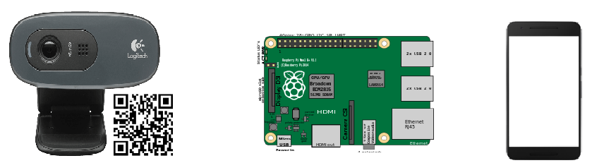

Output

Process

Input

***Build Materials/Budget:***

The materials I’ve used for this project are webcam, raspberry pi, QR codes and PCB. The PCB is not required to do this project; I just used it for the LED for light indicator when the QR code has been scanned. The PCB was provided by the school. The raspberry pi needs a mouse, keyboard and a monitor. My project is not expensive, here’s a table that shows how much I spent:

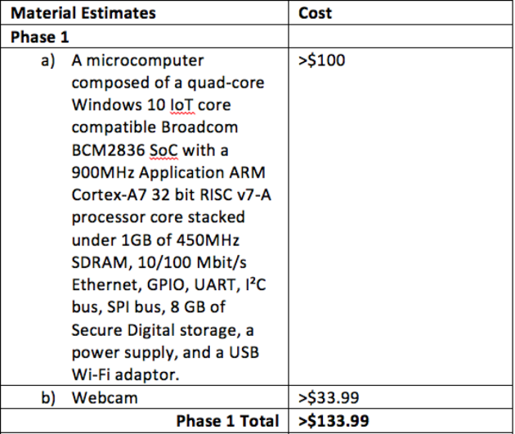

***Time Commitment:***

The project took 15 weeks in total but with the instructions that I will be providing will decrease the time required needed. Most of the time I spent researching and trying to make the code compatible with the hardware. Below is the breakdown how much time I spent:

* Ordering Parts - 2 hours
* Raspberry Pi 3 Setup - 2 hours
* Soldering PCBs - 2 hours
* Testing PCBs - 30 minutes
* Coding – 7 hours
* Remote Desktop - 30 minutes
* Mechanical Assembly - 15 minutes

***Mechanical Assembly:***

The assembly for my project is very simple. First connect the components needed for the raspberry pi which is a mouse, keyboard and a monitor. Then connect the webcam into USB port on the raspberry pi and after connect the PCB on top of the raspberry pi for LED indicator. Lastly connect the power outlet of the raspberry pi.

1. **Raspberry pi Set-up:**

* Sudo apt-get install zbar- tools

This is needed to scan a QR code.

* Sudo apt-get update

Run this command if above command didn’t install properly.

* ls /dev/video*

This command check which video input is your webcam is connected to.

* zbarcam /dev/video*

The * needs to be change to the video input of your webcam is connected to.

1. **PCB Soldering**

* The PCB called Modular Sensor Hat was provided by Humber College. The board must be printed at the prototype lab first. Soldering the PCB was very simple because of the schematic provided to us. Before soldering make sure to wear your safety glasses.

1. **Power Up**

* Once you follow the steps above you can now power up the project. After the raspberry pi is turned on, go to terminal and run the command ./scanner.sh I will be providing a download link below for all the codes used for this project. Once you run the code, zbarcam will pop out in a new window where you can see the webcam input and you can start scanning QR codes. When a QR code gets scanned the LED from PCB will blink and the data from QR code will be saved in a file called “scan-reults.txt”.

***Unit Testing:***

First we checked if the LED in the PCB works by running sudo ./traffic2B command in the raspberry pi terminal. The traffic2B was provided by Humber College. Next we checked if the webcam is compatible with the raspberry pi by installing FSWEBCAM. To install FSWEBCAM type sudo apt-get install fswebcam and upon installing type fswebcam image.jpg to run the webcam. If the webcam works it will take a picture and it will get save.

***Product Testing:***

To test the project, power up the raspberry pi and after the raspberry pi is turned on go to terminal and type “./scanner.sh” a download link below will be provided. After running the script place a QR code in front of the webcam and when the QR code gets scanned successfully the LED from PCB will blink and the data will be saved to a file txt called “scan-results.txt”